



Microsoft Dynamics 365 for

Sales

Microsoft Dynamics 365 for Sales empowers   
sellers with the insight, guidance and tools to drive personal engagement with their customers.

|  |  |  |
| --- | --- | --- |
| “We can use data to make data- driven decisions and communicate  to our teams using actual data. Everyone here is very smart, but the additional insights — based on a single shared version of the truth — make us all smarter.”  Rick Stow  Head of CRM, Grant Thornton   |  | | --- | |  | | **Key Benefits**  **GROW BUSINESS**  Leverage intelligent insights and business processes to increase revenue while reducing acquisition cost.  **STAY FOCUSED**  Reduce distractions and know where to prioritize in a  fast-paced sales environment.  **WIN FASTER**  Close deals faster and increase revenue through sales collaboration and productivity. |

|  |  |
| --- | --- |
| **Key Capabilities** |  |
|  |  |
|  |  |
|  | **ACTIONABLE INSIGHTS**  Derive meaningful intelligence from massive amounts of complex data by delivering simple to understand and act upon insights. Insights are in context of your customer relationship so that it’s easy to focus on the right priorities and drive personal engagement. |
|  | **PERSONAL ENGAGEMENT**  Great customer engagement allows your customers to engage with you on their terms while empowering your sellers with customer behavior, trends and potential value to build and develop customer relationships |
|  | **CUSTOMER MANAGEMENT**  Automate your sales processes to shorten the sales cycle, boost productivity, and reduce costs. Microsoft Dynamics 365 for Sales features a highly intuitive interface with Microsoft Office 365—embedded capabilities. |
|  | **SALES PERFORMANCE**  Delivers insight and analytics to provide real time and  historical as well as predictive and proactive information. Meet objectives and achieve your goals by motivating and energizing your entire team. |

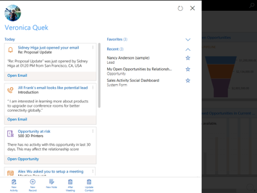

|  |  |
| --- | --- |
| **Dynamics 365** | **Better Together** |
| Microsoft Dynamics 365 is the next generation of intelligent business applications that enable your organization to grow, evolve and transform. These applications unify CRM and ERP capabilities with purpose-built applications that work seamlessly together to help manage specific business functions and allow your organization to transform to meet customer needs and capture new opportunities. | * **Field Service:** Identify and create opportunities  in the field for sales teams. * **Project Service Automation:** Help sales and delivery teams engage customers and deliver billable projects  on time and within budget. * **Customer Service:** Get a complete view of your customers, including activity history, key contacts, communications, and internal account discussions. * **Operations:** Gain control of the end-to-end business processes on the sell side, from prospect to cash * **Marketing:** Enable marketing and sales to work  closely to manage all prospect interactions throughout the customer journey. |

**For more information, visit:** <https://www.microsoft.com/en-us/dynamics365/sales>